Requirement Analysis

Data Flow Diagrams and User Stories
Date: 02 November 2025
Team ID: NM2025TMID03190
Project Name: Laptop Request Catalog Item
Team Members: Indra & Buvana
Maximum Marks: 4 Marks

1. Data Flow Diagrams (DFD)
The Data Flow Diagrams represent the flow of information in the Laptop Request Catalog Item system. It shows how data moves between different processes, users, and the system database. The diagrams help in understanding how the ServiceNow catalog item manages requests, approvals, and fulfillment of laptop allocations.

1.1 Level 0 – Context Diagram
The Level 0 DFD (Context Diagram) provides an overview of the entire Laptop Request Catalog Item system. It highlights the interaction between external entities such as Employees, Managers, and the IT Asset Management team. The system acts as a central process that manages requests and communicates with the asset database.
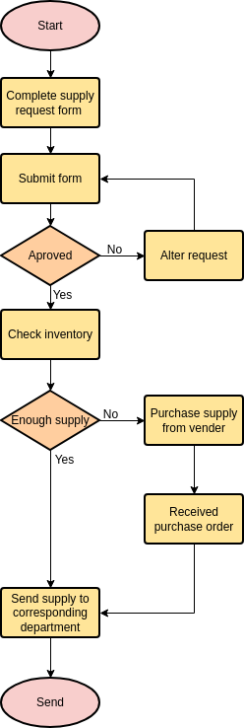

1.2 Level 1 – Process Breakdown
The Level 1 DFD expands the main process into multiple subprocesses, such as submitting requests, approving requests, checking laptop availability, and fulfilling the request. Each subprocess shows the data input and output flow between entities.
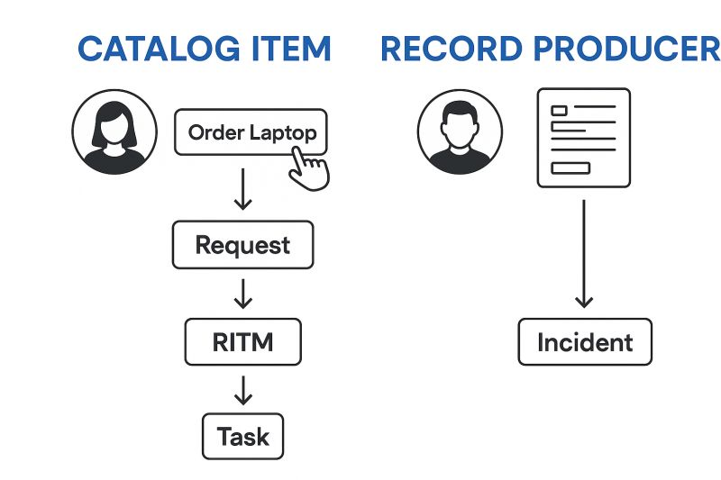

2. User Stories
User stories describe the functionalities of the Laptop Request Catalog Item from differe
User Story ID | As a (User) | I want to (Goal) | So that (Benefit)
US1 | Student | Request a laptop through the online catalog | I can easily apply for a laptop without manual forms
US2 | Student | Track the approval and delivery status of my request | I can know when my laptop will be issued
US3 | Student | Receive notification when my request is approved or rejected | I can stay informed without checking the portal frequently

3. Summary / Observation
The Data Flow Diagrams and User Stories together define the structure and expected functionality of the Laptop Request Catalog Item. The DFDs illustrate how data moves between employees, managers, and the IT team, while the user stories capture each user’s specific needs. This analysis ensures that the solution meets functional and workflow requirements effectively.

